North America Map
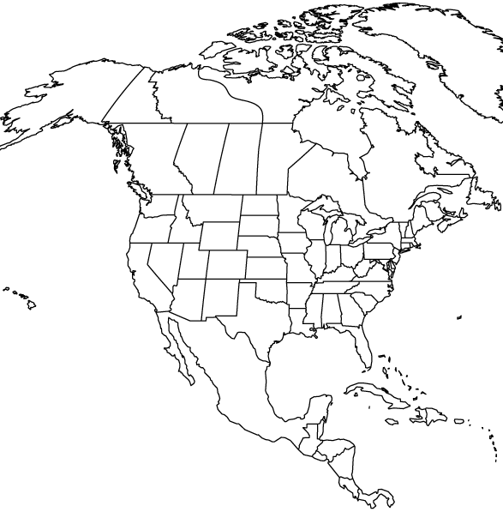
- Please label the map with the 72 locations found on the following page.
- Label provinces states, and bodies of water.
- Mark cities with dot or a letter. (You may wish to make a legend for neatness)
- Mark Rivers with a Blue line and draw circles for smaller lakes.
- Mark Mountains by shading in the range or drawing triangles along the range

(Spell correctly the full names of places, but spelling of place names will not be graded on the test)

