Canada's House of Commons Worksheet
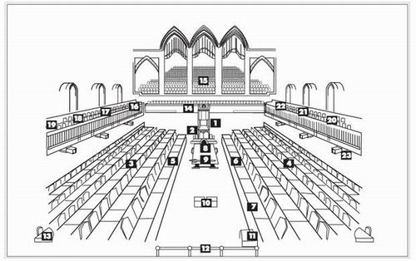
Please label all of the numbers.
1. _______________________________________________

3.________________________________________________

4.________________________________________________

5.________________________________________________

5b._______________________________________________

6.________________________________________________

6b._______________________________________________

7.________________________________________________

7b._______________________________________________

8.________________________________________________

9.________________________________________________

10._______________________________________________

11._______________________________________________
Answer the following questions in your own words.
- The House of Commons is the only part of the Legislative Branch that is _________________. This must occur every ___ years. An area of roughly 100,000 people is referred to as a ________________ or __________________________ , and eligible voters in each elect one person to represent them in Parliament. These representatives are then called __________________________________________ or MPs and make up the lower house or House of Commons. The number of seats (MPs) in the house is determined by the countries _____________________.
- What is a "Speaker of the House" and what are his duties?

- What is the name of the group who sits across from the Party in Power (Party with the most seats in the House of Commons) and what is their function?
Name: _________________________ Leaders Title: ______________________________________
Function:
- Why is question period in the House of Commons critical (important) to Canada’s democracy?

