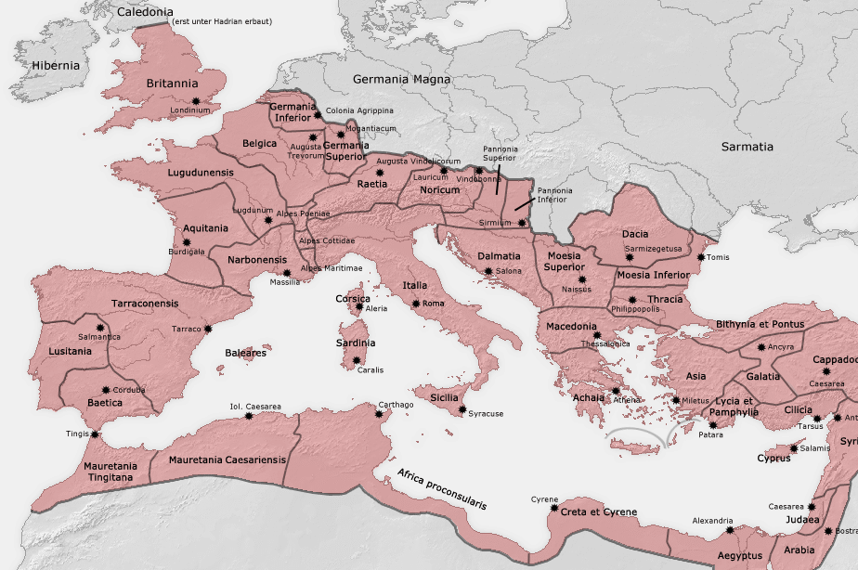

You are emperor of Rome connect Rome to the locations by roads and shipping routes. Every cm of Road will cost your empire 500 talents of gold Every time you cross a river it will cost an addition 50 talents of gold. Every cm of shipping route will cost you 300 talents of gold.

- Athens is a city of enormous culture and spiritual significance connect to it with a shipping route. (calculate the expense)
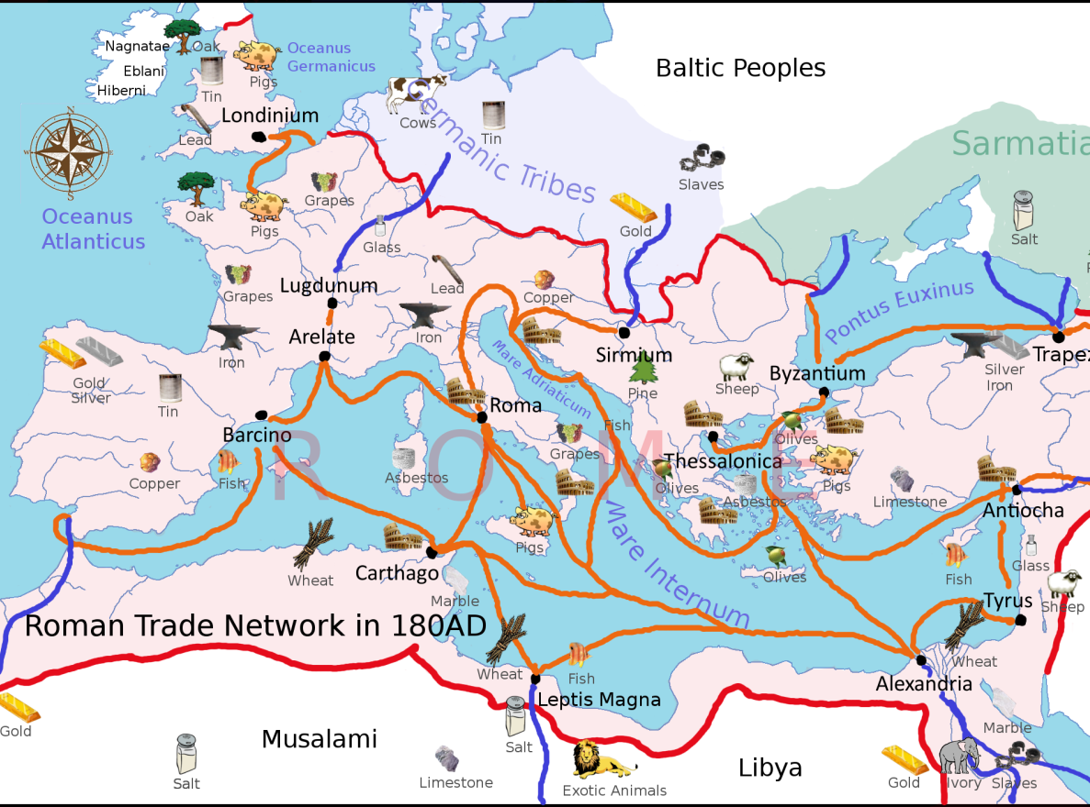
- Connect to the Phillipians, Constantinople, and the Galatians with a road. (calculate the expense)
- You have recently destroyed the Carthingians. Connect to the city of Carthage with a shipping route. (calculate the expense)
- Connect a shipping route from Rome to Constantinople to Alexandria (calculate the expense)
- You want to expand the Roman Empire onto the Island of the Anglo Saxons, connect Rome by Road to Tingis and then connect Tignis by shipping route to Londinium. (calculate the expense)
- You need more slaves connect your roads to an area that has them. (Calculate the expense use the map below)
- You need more savage beasts like Rhinos and lions for your coliseums, connect a road from Carthage or Alexandria to central Africa. Calculate the expense)
- Your navy needs stronger wood for your ships and war machines. Connect your roads or shipping routes to the nearest source of oak trees. You can use previous roads. (Calculate the expense, use the map right)
- The province of Judaea is having numerous Jewish revolts. Connect Judaea to Rome with a road and a shipping route, you can use previous roads and shipping routes. (Calculate the expense)
- What is the total expense of all your roads and trade routes combined?

