Grade 9 Mapping Assignment
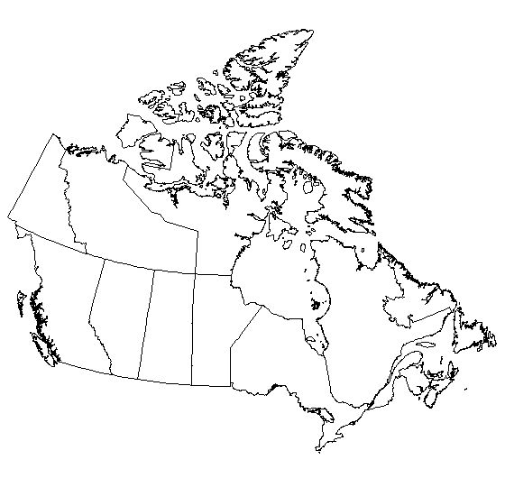

Locate the following on the modern map
- Label all the Provinces
- Label all Capitol Cities
- Label Baffin Island
- Label Elsmere Island
- Label St Laurence River
- Label All the Great Lakes
- Label Hudson Bay

Locate the following on the world map.
- Arctic Ocean
- North Sea
- Pacific Ocean
- Atlantic Ocean
- Mediterranean
- Bearing Strait
- Caribbean
- England
- France
- Paris
- London
- Portugal
- Spain
- Cuba
- Brazil
- Madrid
- New York

