Grade 8 Mapping Assignment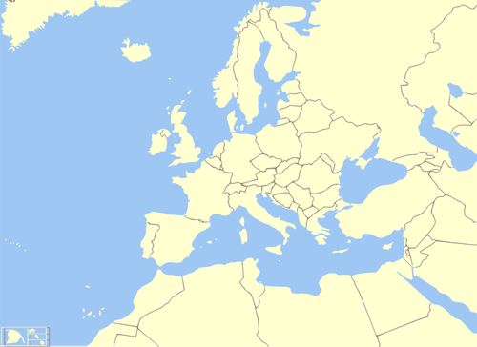
- England
- Scotland
- Ireland
- Italy
- Israel
- Russia
- Turkey
- Azores
- Germany
- Istanbul/
Constantinople
- Jerusalem
- Antioch
- Rome
- Venice
- Mecca
- Bagdad
- London
- Paris
- Mediterranean
- Red Sea
- North Sea
- Atlantic Ocean
- Adriatic
- Aegean
- Danube River
- Rhine River

