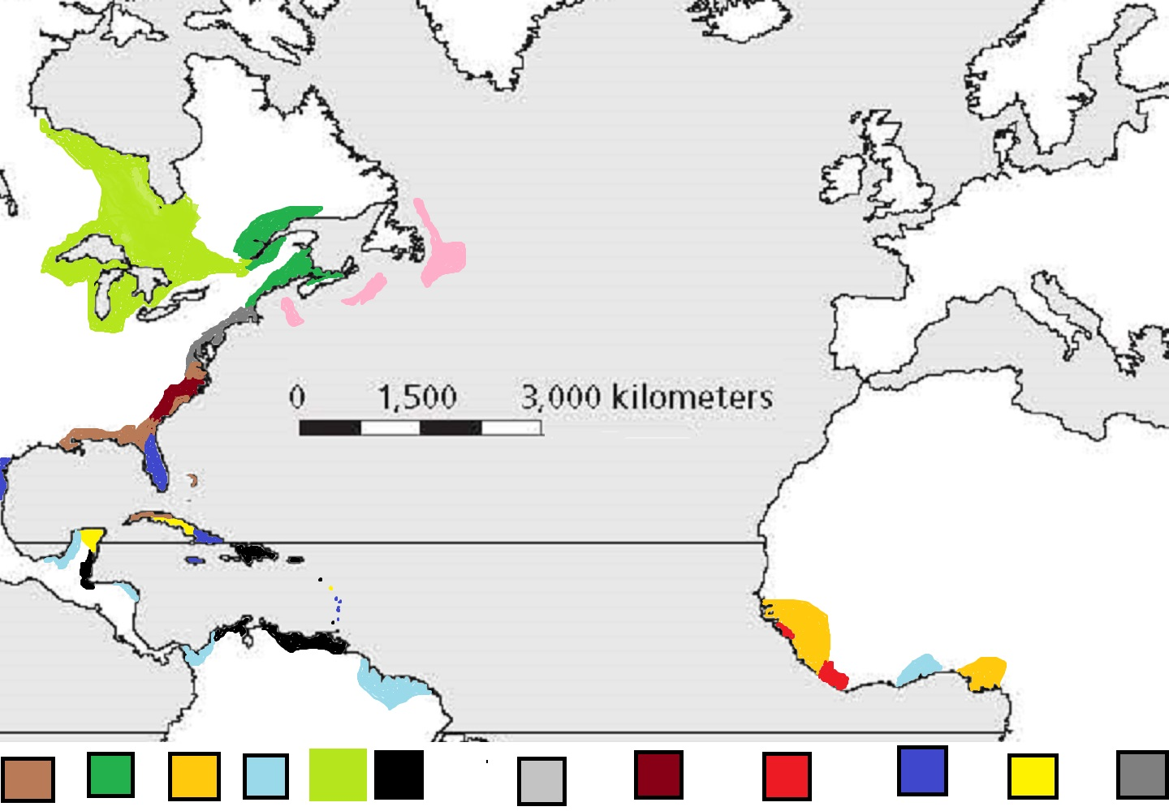 Cotton Trees Slaves Gold Furs Coffee Fish Tobacco Ivory Sugar Molasses Corn
Ivory Coast
Bruges
Marsielles
Cadiz
Lisbon
London
Montreal
Boston
New York
Norfolk
Havanah

Disclaimer: The map was made by myself. The exact geographic locations of where these resources were gathered are approximate. They give students a general idea. Islands like Jamaica for example produced a whole range of exported resources, especially sugar. The 13 colonies also produced a range of resources far beyond the scope of this assignment

The Rules:
To win the game you need to complete 10 contracts. Keep in mind certain contracts, when completed, are worth double. Double Contracts will have a triple star beside them (***) Every 6 turns contracts will expire and new contracts will come up.
Starting the game begins with choosing a nation. You can choose between Spanish, Portuguese, Dutch, English and French traders. You will start the game on that countries most famous port city. The teacher will list available contracts on a ppt.
What to do during a turn. 1. Sailing: You can sail a maximum of 3000 km in a turn. Once you have sailed 3000km your turn is over and you indicate where your turn ended with a dot made with a pencil. You MUST sail in a straight line. You can change direction every 750km. 2. Picking up resources: You pick up resources by sailing into the coastline of the color of resource you wish to pick up. When you pick up a resource write on a sticky note what you picked up. (you can have 3 resources at any time) Picking up a resource marks the end of your turn even if you could have sailed further. 3. Deliver a resource: If you have a resource, you can drop it off at a town that is demanding it. Hand in the sticky note to the teacher and he will give a point for your country and remove the contract from the board. Once you drop off a resource your turn is over regardless of how many Kms you have left to sail.
Other rules you can hold up to 3 different resources on your ship. So feel free to pick up multiple resources. Important - you cannot pick up double resources in a single turn. (If you want two resources you must wait a full turn) ALL European cities always carry Manufactured Goods, so when you’re in Europe make sure to pick these up. Remember contracts change every 6 turns, even if you are close to a city when the contract expires you cannot collect points.

